**Cloud Computing**

Session 2

Assignment 1 : Creating an Amazon Web Services Free Account

I have gone through the following procedure to create an AWS Free Tier Account.

The screen shots are to better understand the procedure.

**Step 1**:

Review the AWS Free Tier Features and products along with the Free Tier Limits in

<https://aws.amazon.com/free/>

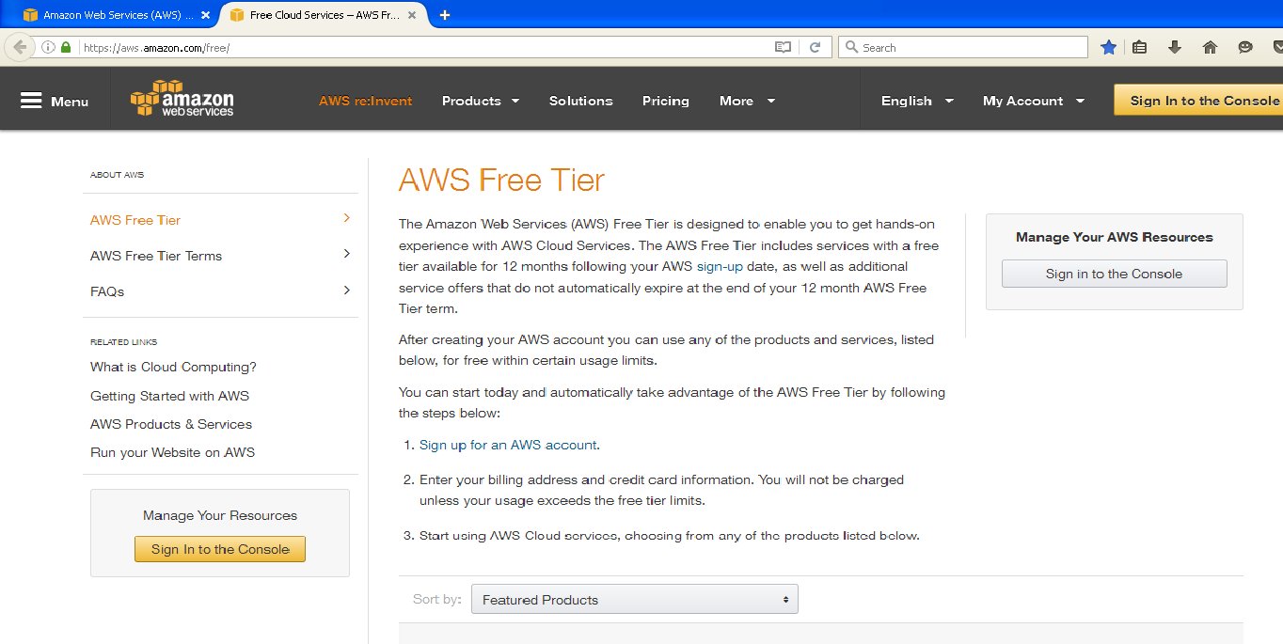

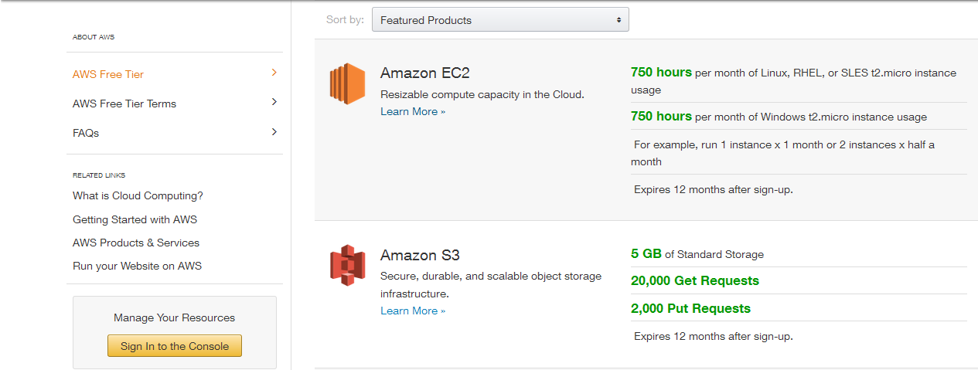

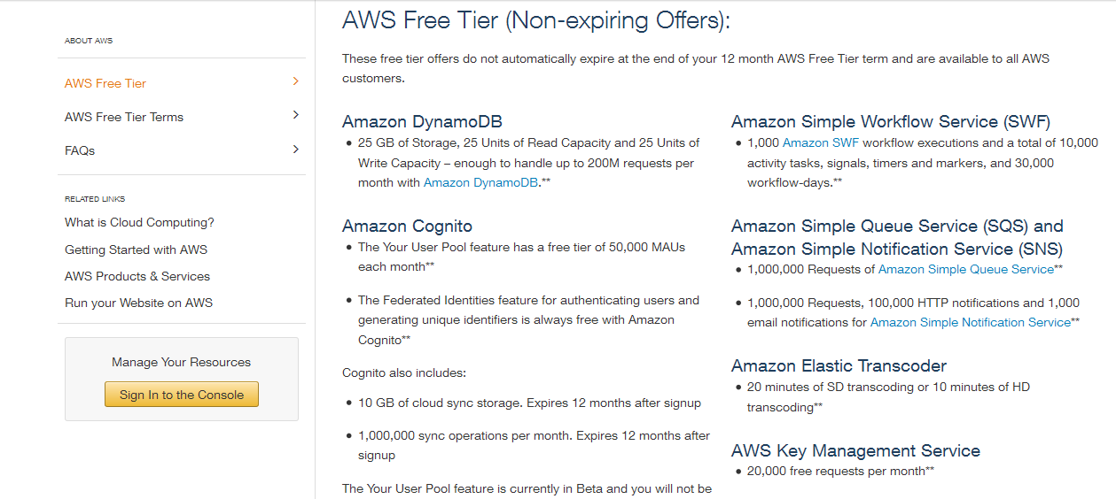

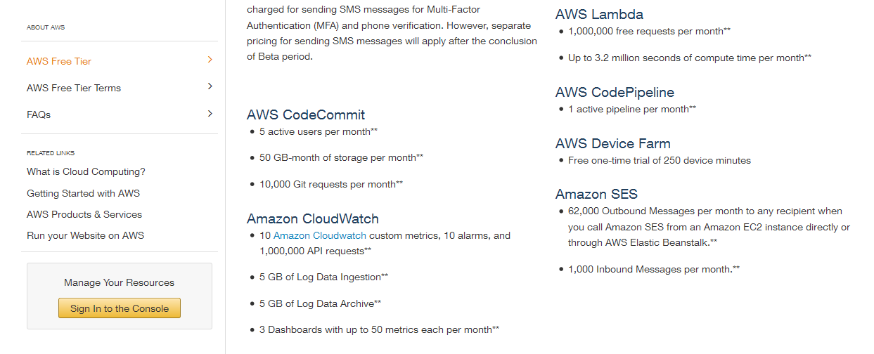

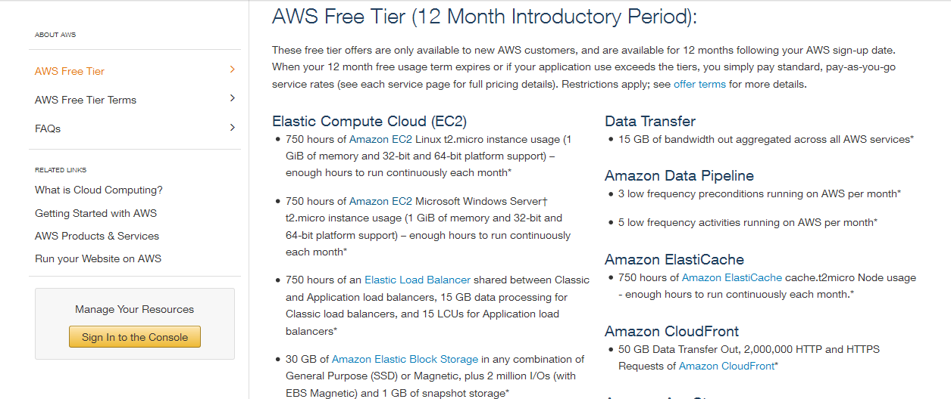

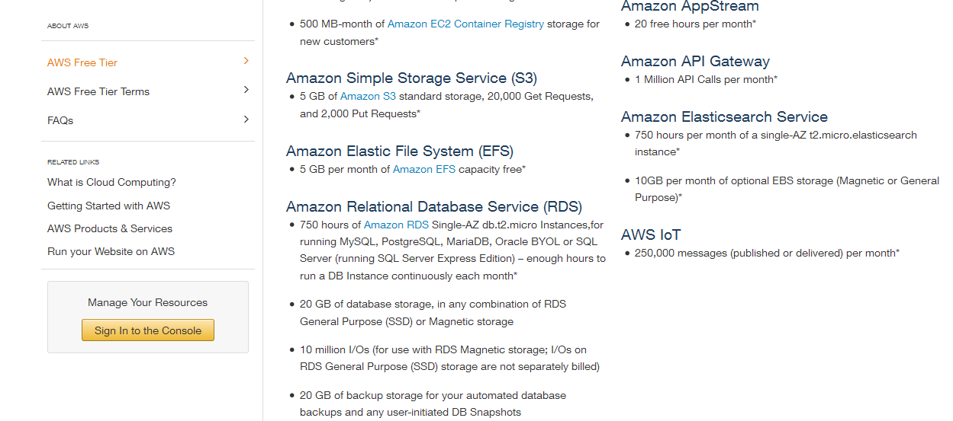

**Step 2**:

Go to <https://aws.amazon.com/> to start Creating A Free Account in Amazon Web Services.

Click on Create A Free Account.

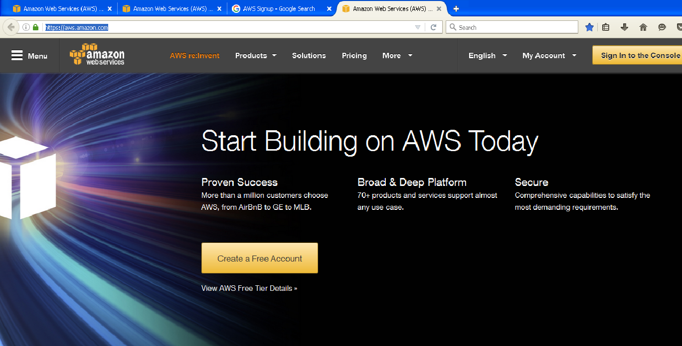

**Step 3**:

Select the “ New User Option “ and provide the eMail id to Sign in to the Secure Server of

Amazon Web Services.

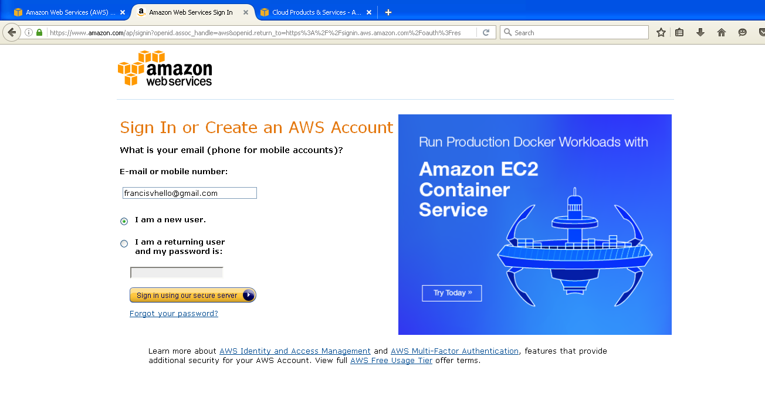

**Step 4**:

Fill the Login Credentials for Amazon Web Services Account.

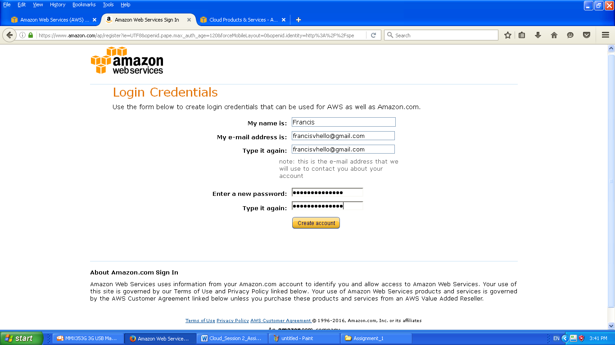

**Step 5**:

Fill the Contact Information for Amazon Web Services Account and click on

“ Create Account and Continue. ”

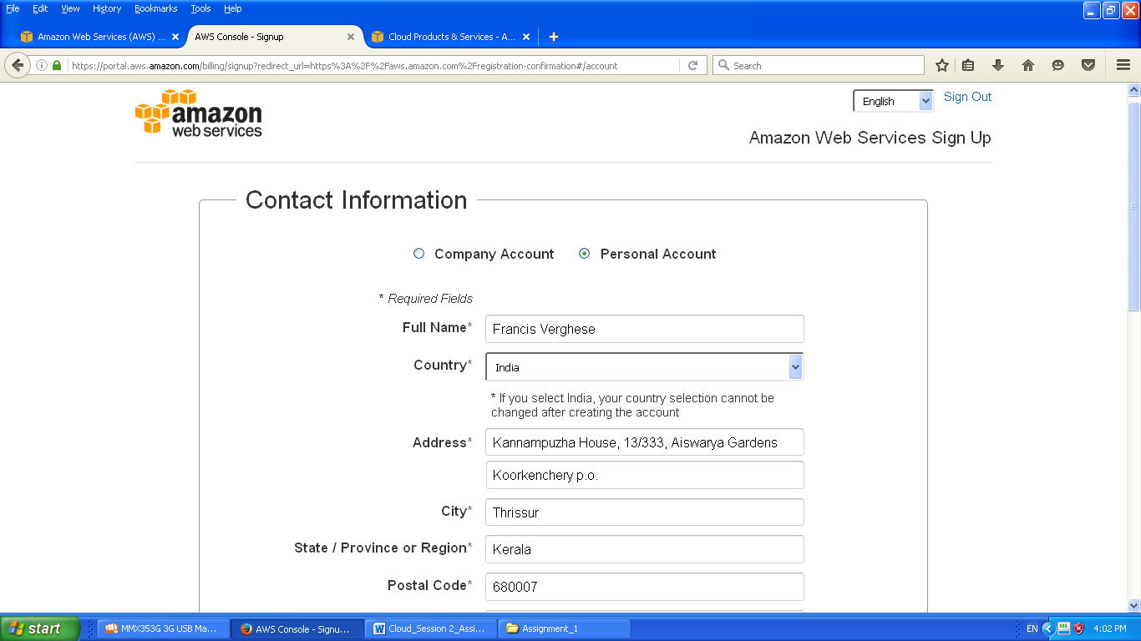

**Step 6**:

Provide the Payment and PAN Information for Amazon Web Services Account and click on

“ Verify Card and Continue. ”

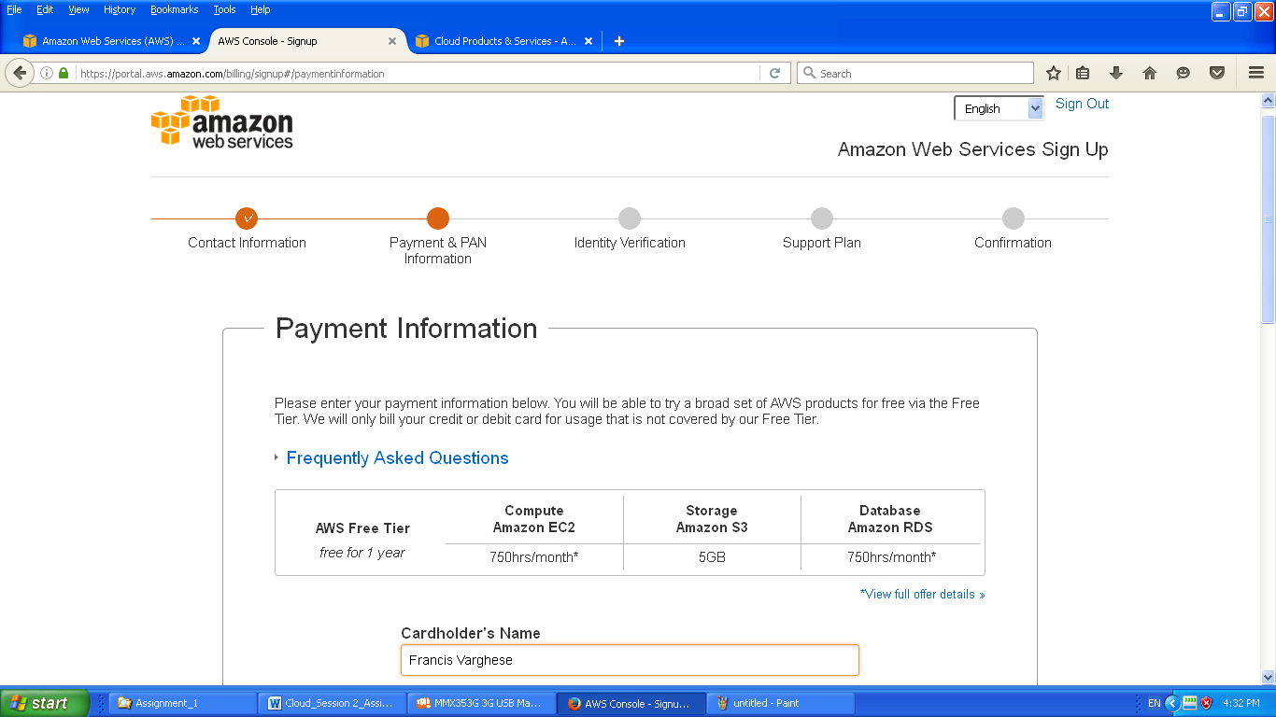

**Step 7**:

Complete the Identity Verification by providing the PIN Number when prompted in the

Verification Call.

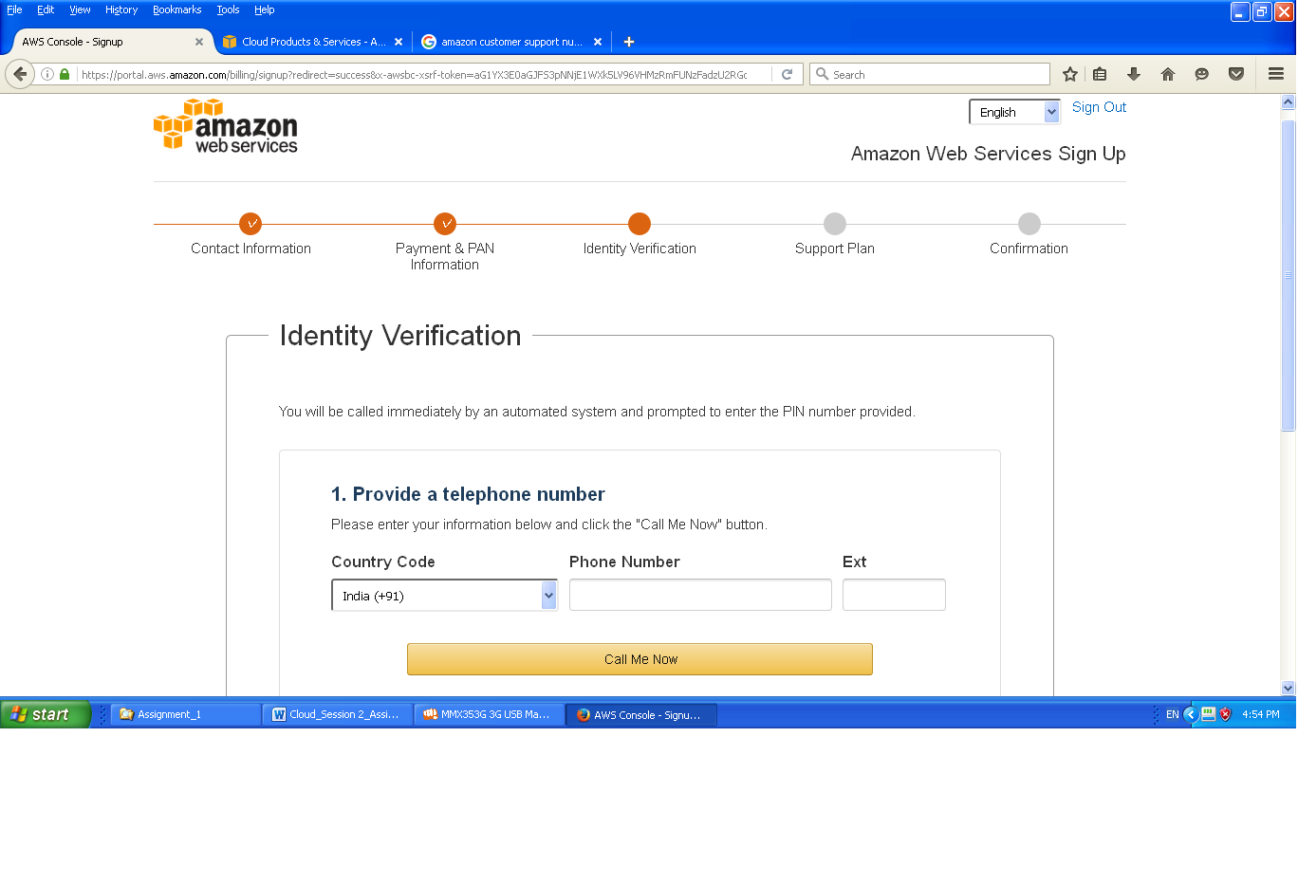

**Step 8**:

Click on “Continue to Select your Support Plan “ after the Identity Verification is complete.

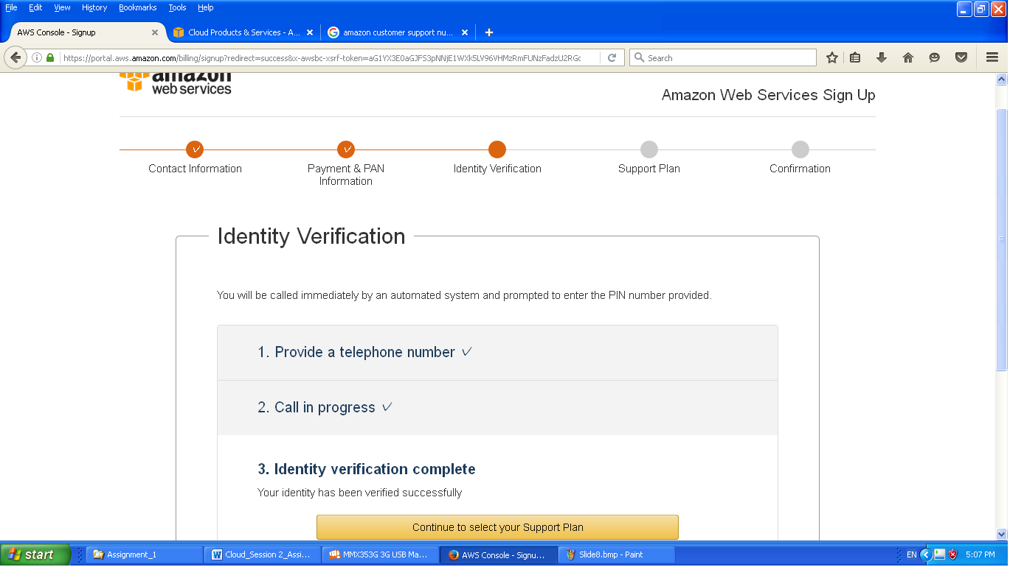

**Step 9**:

Select a suitable the Customer Support Plan for the AWS Account and click on “Continue”

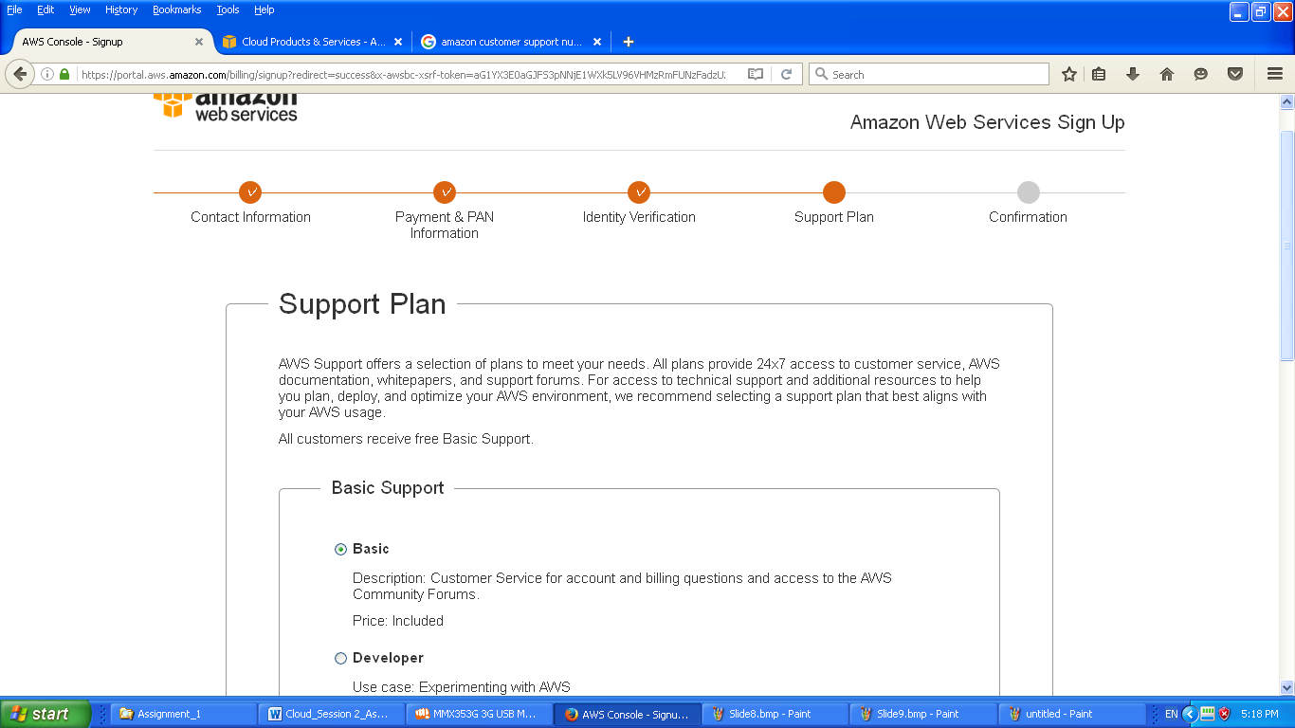

**Step 10**:

Registration Confirmation Message from Amazon Web Services. Click on “Sign In to the Console”

to check the AWS account details.

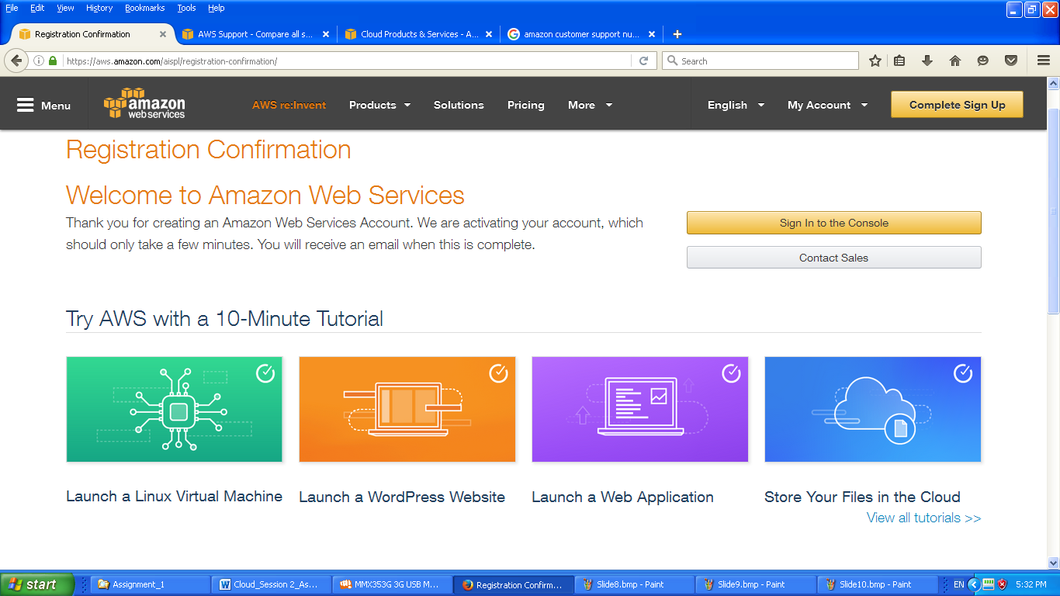

**Step 11**:

Verify the Account Information in the AWS Console. Click on “Name” and select

My Account from the Menu.

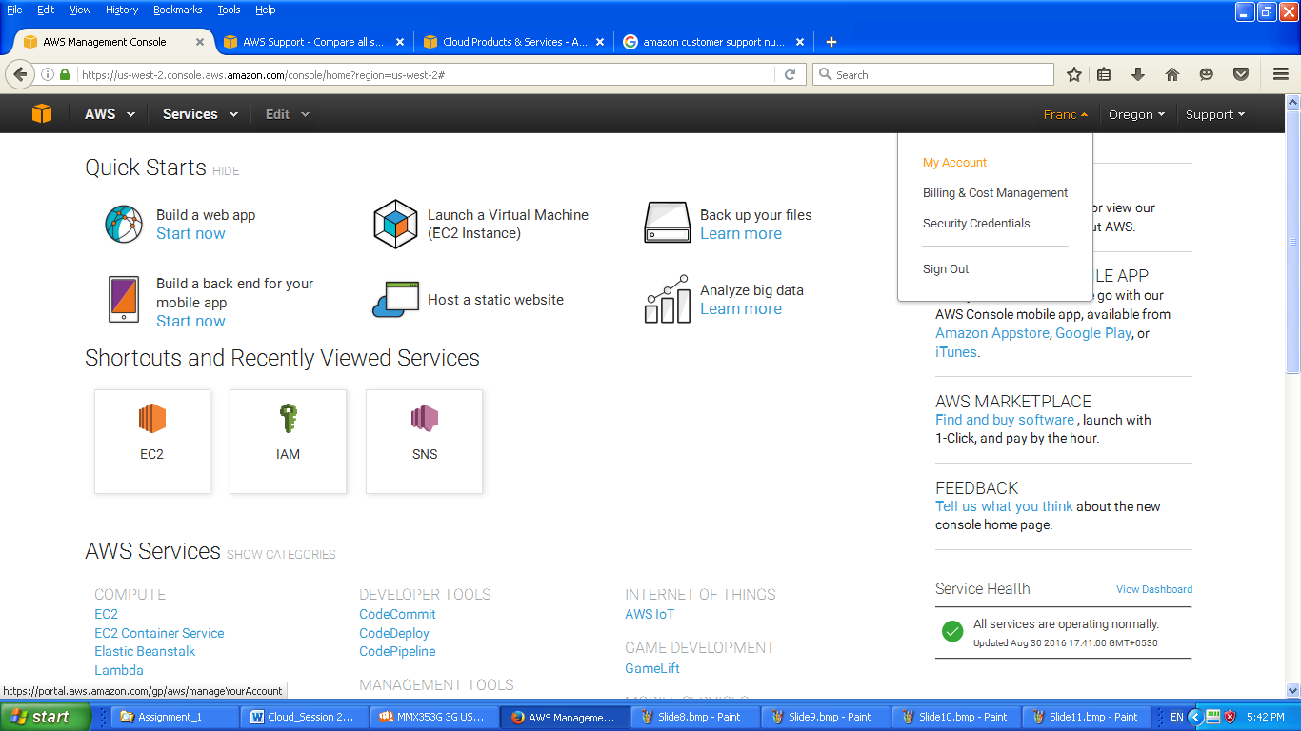

**Step 12**:

Check the Account Information in the AWS Console.







